**Linux Lab # 1.1**

**Directions:**

* The command line is one of the most powerful tools available for you to use with Ubuntu. In this lab you will learn about the most frequently used Linux commands and interpret their execution outputs. First you need to access your terminals by pressing **Ctrl+ Alt+ T**. If you have still difficult accessing your terminal, please read the following resources (URL below):

* + How do you open a command line? - Ask Ubuntu. (n.d.). Retrieved from

<http://askubuntu.com/questions/196212/how-do-you-open-a-command-line>

* And, to help you learn / interpret both the commands and their corresponding execution outputs please read your textbook Appendix A and also read the following resources posted at the URL below:

* + Basic UNIX Commands with Examples - Part I. (n.d.). Retrieved from [http://www.livefirelabs.com/unix_commands/basic-unix-commands-with-examples-part-](http://www.livefirelabs.com/unix_commands/basic-unix-commands-with-examples-part-1.htm)

[1.htm](http://www.livefirelabs.com/unix_commands/basic-unix-commands-with-examples-part-1.htm)

* For this lab/tutorial you need to create a script, a file that is used to take a copy of everything which is output to the terminal and place it in a log file.

* Now first move to your home directory ***cd ..***and then as shown in the fig below, and to create a script file type the following at the command prompt :

***$ script***

**L**

**i**

**nux Lab #**

**2**

***Tutorial***



(

hit enter)

*and follow*

*the*

*steps*

*below*

:

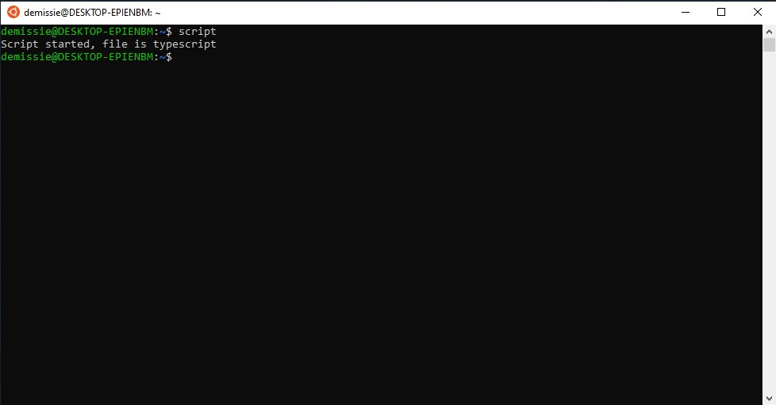

1. Enter these commands at your **Linux prompt**, and try to interpret the output:

|  |  |
| --- | --- |
| **$** | **echo hello world** |
| **$** | **passwd (** you need tochange your password, ***Ctrl-d*** takes you back to the prompt**)** |
| **$** | **date** |
| **$** | **hostname** |
| **$** | **arch** |
| **$** | **uname -a** |
| **$** | **dmesg | more (**you may need to press ***q*** to quit**)** |
| **$** | **uptime** |
| **$** | **whoami** |
| **$** | **who** |
| **$** | **id** |
| **$** | **last** |
| **$** | **finger** |
| **$** | ***w*** |
| **$** | **echo $SHELL** |
| **$** | **man ls** (you may need to press ***q*** to quit) |
| **$** | **man who (**you may need to press ***q*** to quit**)** |
| **$** | **who can tell me why i got divorced** |
| **$** | **echo {con,pre}{sent,fer}{s,ed}** |
| **$** | **lost** |
| **$** | **clear** |
| **$** | **cal 2000** |
| **$** | **cal 9 1752 (**do you notice anything unusual?) |
| **$** | **bc -l (**type quit or press ***Ctrl-d*** to quit**)** |
| **$** | **yes please (**you may need to press ***Ctrl-c*** to quit**)** |
| **$** | **time sleep 5** |
| **$** | **history** |

1. Try the following command sequence:

**$ cd**

**$ pwd**

**$ ls -al $ cd .**

**$ pwd (**where did that get you?) **$ cd ..**

**$ pwd**

**$ ls -al $ cd ..**

**$ pwd**

**$ ls -al $ cd ..**

**$ pwd (**what happens now?**) doesn’t change directory**

**$ cd /etc**

**$ ls -al | more**

**$ cat passwd**

**$ cd -**

**$ pwd**

1. Continue to explore the files system tree using cd, ***ls, pwd and cat***. Look in ***/bin, /usr/bin, /sbin, /tmp*** and **/boot**. What do you see?

1. Make subdirectories called work and play.

1. Delete the subdirectory called work.

1. Copy the file **/etc/passwd** into your home directory.

1. Move it into the subdirectory play.

1. Create a file called **hello.txt** that contains the words **"hello world".**

1. Delete the work directory and its contents with one command.

1. Experiment with the options on the ***ls*** command. What do the ***d, i, R and F*** options do?

**To stop the script file… simple type *exit* at the command prompt.**

**Please note, you will be submitting your script file via Blackboard.**